Decision making statement
_____________________________________________________________________________
Decisions making statement is used for check the condition or work by using condition or write code by using conditions.

There are five types of decision making statement
________________________________________________________________________________
1. Simple If:
Syntax:
if(condition){
write here your logics
}
other program statement.

Example: WAP to input number and check number is even or odd
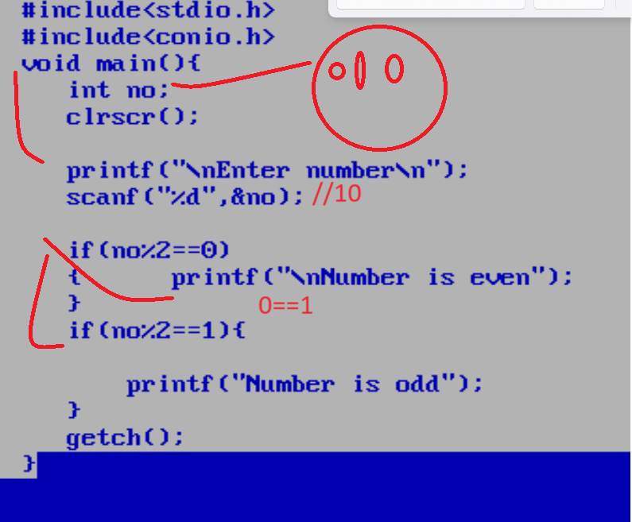
Example: WAP to input three sides of triangle and check triangle is valid or not
180
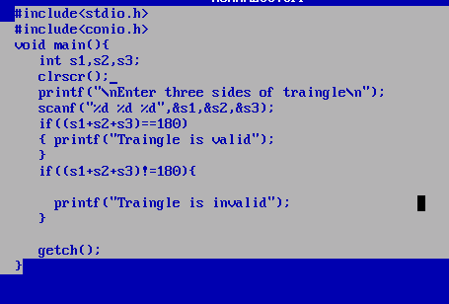

2. If else: if else block is used for when we have two conditions exact opposite of each other
Syntax:
if(condition)
{ true condition
}
else{
false condition
}
other program statement
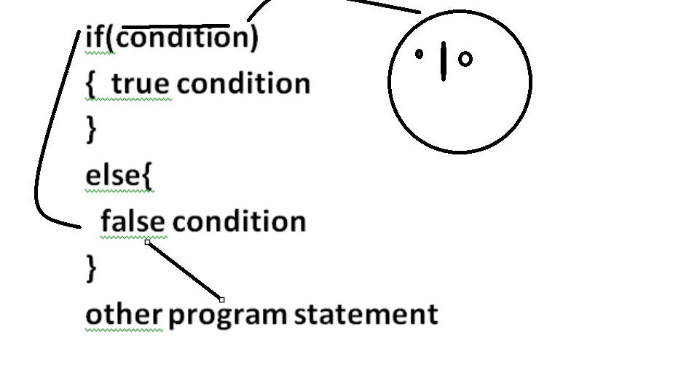
Example: WAP input two numbers and check which is greater
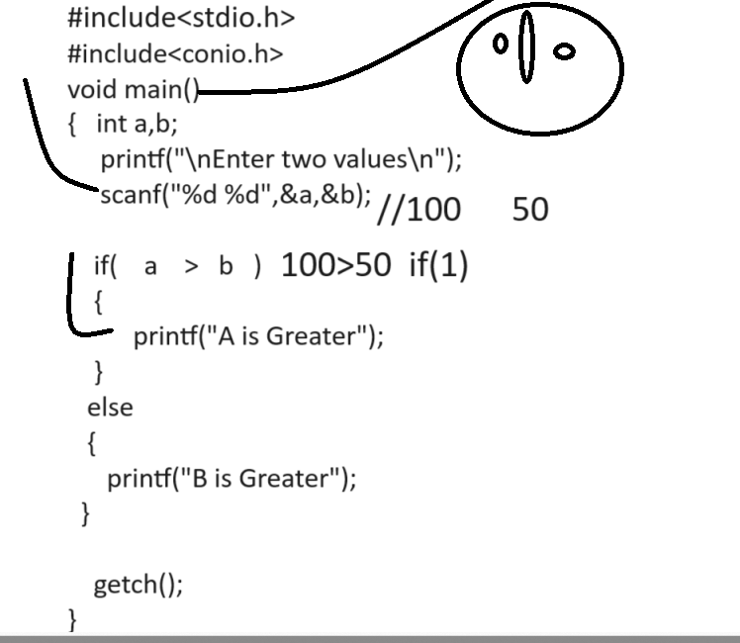

Example:
There is a JAR full of candies for sale at a mall counter. JAR has the capacity N,
that is JAR can contain maximum N candies when JAR is full. At any point of time.
JAR can have M number of Candies where M<=N. Candies are served to the customers. JAR is never remain empty as when last k candies are left. JAR if refilled
with new candies in such a way that JAR get full.
Write a code to implement above scenario. Display JAR at counter with available number of candies.

Input should be the number of candies one
customer can order at point of time. Update the JAR after each purchase and display JAR at Counter.
Output should give number of Candies sold and updated number of Candies in JAR.
If Input is more than candies in JAR, return: “INVALID INPUT”
Given,
N=10, where N is NUMBER OF CANDIES AVAILABLE
K = 5, where k is number of minimum candies that must be inside JAR ever.
Example 1:(N = 10, k = 5)
• Input Value
o 3
• Output Value
o NUMBER OF CANDIES SOLD : 3
o NUMBER OF CANDIES AVAILABLE : 7
Example : (N=10, k<=5)
• Input Value
o 0
• Output Value
o INVALID INPUT
o NUMBER OF CANDIES LEFT : 10

Source code

Example: WAP input character from keyboard and convert lower case character to upper case and upper case character to lower case
Input: a
Output: A

If we want to work with any character or if we want to perform operation on character we need to work with ASCII code.

Q. what is ASCII code?
_____________________________________________________________________
ASCII stands for American standard code for information and interchange.
ASCII is intermediate language which is used for store every key on keyboard as digit in memory.

There are total 256 ASCII code
A =65 to Z = 90
a=97 to z =122
0=48 to 9=57

3. Else if ladder
4. Nested if
5. Switch

